Accelerometer:

An accelerometer is a compact device designed to measure linear acceleration. When the object it's integrated into goes from a standstill to any velocity, the accelerometer is designed to respond to the vibrations associated with such movement. It uses moving mass that go under ocillation when there is a certain acceleration, and from that oscillation of the mass system a voltage is generated due to the change of capacitance to create a reading on any acceleration. Accelerometers are important components to devices that track fitness and other measurements in the quantified self-movement.

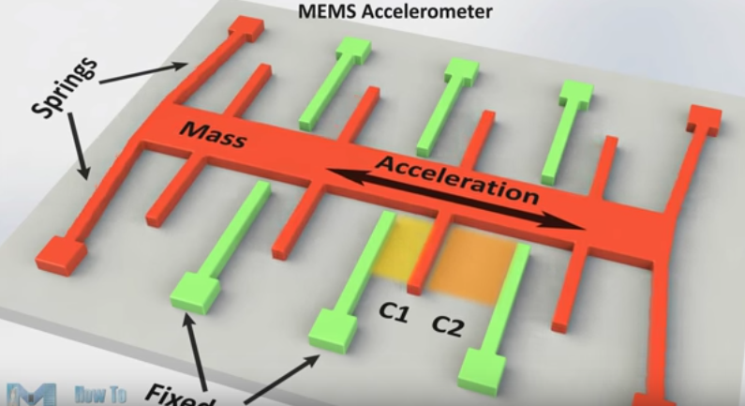

C = (A/d)

A= overlapping area

d= separation between fingers

𝒍 = opelaping length of the conductor

𝒘 = overlapping width of the conductor

𝑨 = 𝒘 ∗ 𝒍

C change depends on ‘***l’, ‘w’*** *& ‘d’.*

Capacitance change

𝑪′ = (𝒘∗ 𝒍−Δ𝒍)/𝒅

𝑪′ = (𝒘−Δ𝒘 ∗𝒍)/𝒅

𝑪′ = (𝒘∗𝒍)/(𝒅−Δ𝒅)



**Gyroscope:**

A **gyroscope** is a device used for measuring or maintaining orientation and angular velocity.

Angle of precession is the angular velocity of the axis of rotation.

This sensor work on basis of coriolis effect.

Coriolis acceleration: It is an aparent acceleration that arises in the rotating frame of refrence.

Coriolis force: force act to a body due to coriolis acceleration.

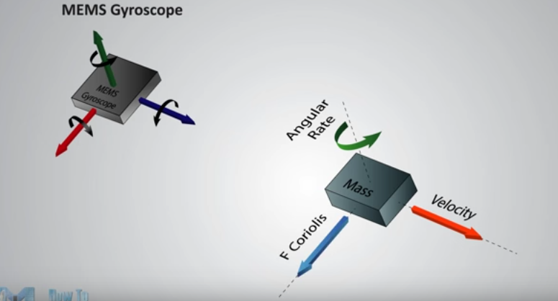

This coriolis force is perpendicular to the velocity vector and direantion of angular velocity.

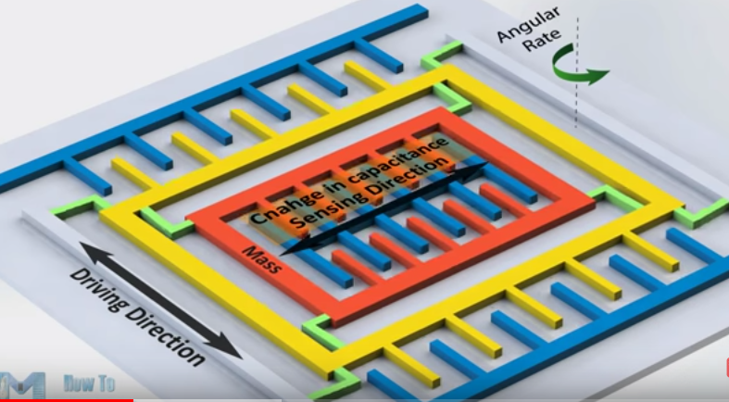

Due to the coriolis effect the mass shifted towards the coriolis force creating a low current electrical signal that can be use to indicate certain angular velocity.